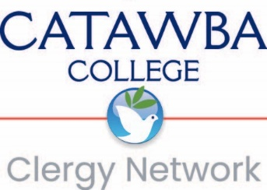

2025 COP Grant Application Worksheet

Use this form to collect your ideas, then cut and paste the contents of this worksheet into the application.

- Project Title: Type Here

- Participants: Will this project be completed in conjunction with the community of practice in which you participate? If so, please list the names of COP members below who will participate in the grant project.

Type Here

- Grant amount requested (up to $500 per participant): Type Here

- Type of funding requested:

☐ | Community Fellowship
☐ | Continuing Education
☐ | Curiosity, Innovation, Creativity

- Proposal Narrative: Describe the project that will be funded, including how the funds will support opportunities for community fellowship, continuing education, or the cultivation of curiosity, innovation, and creativity.

Type Here

- Proposed Budget: Identify how the funds will be allocated, i.e. administrative costs, event costs, personnel costs. Use the Budget Worksheet.

Type directly into the Budget Worksheet.

- Project Goal: Determine what goal the participants aim to achieve by participating in this COP project.

Type Here

A completed W-9 must be submitted as a PDF for each participant named in the application.

